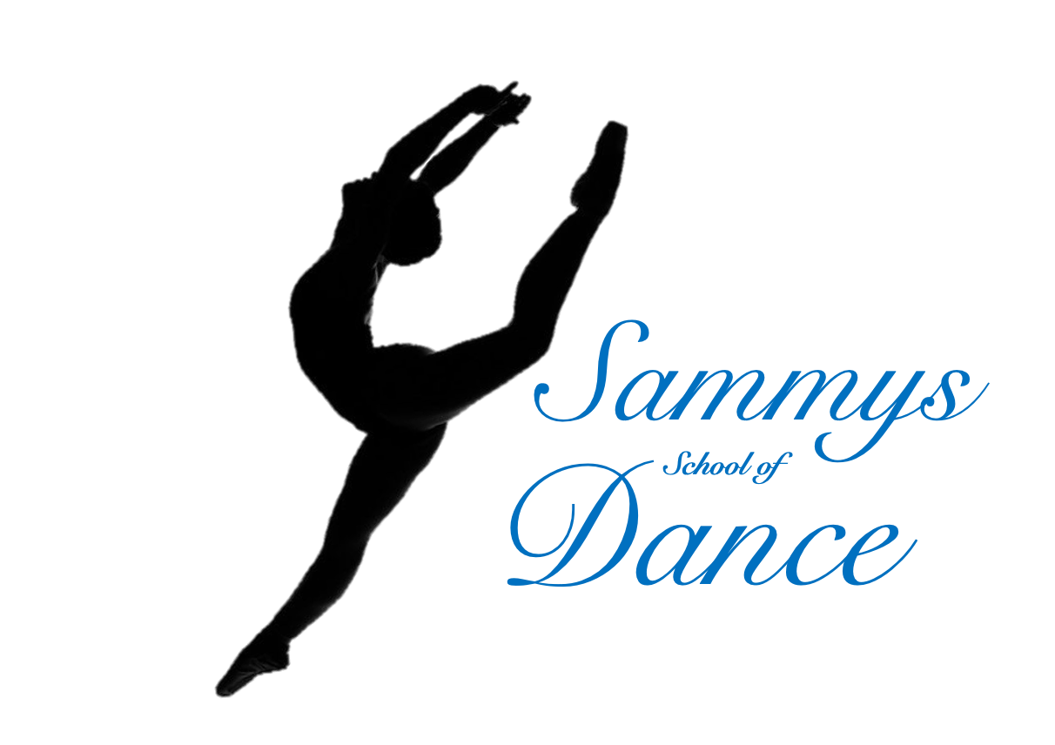

Health and Safety Policy
Sammy’s School of Dance

Updated: August 2022

This is the Statement of General Policy and Arrangements for: |  |  | Sammy’s School of Dance
Responsibility of: |  | Miss S Pickard, Miss O Loader, Mrs S Ellis, Miss M Forder
Statement of General Policy | Responsibility of |  |  | Action/Arrangements (What are you going to do?)
Prevent accidents from obstructions, lighting and floor space | All Teaching Staff |  |  | Make sure class space is clear from obstructions and spills before each session.  Check there is adequate lighting in the class space.
Provide Safe Dance Practice, including prevention of injury | All Teaching Staff |  |  | Teaching staff to check before each session if any students are carrying an injury.  Teaching staff to ensure classes are carried out in a safe manor. Use of Space, Correct clothing/shoes/hair tied back etc…
Provide a safe area for changing. | All Teaching Staff |  |  | Parents will sit in the school hub reception.  Toilets to be cleaned regularly.
Provide first aid and accident reports | Miss Samantha Pickard |  |  | Principal to carry an accident book  First Aid Box and Trained Staff available at all times  First Aid box situated at Oasis reception
Implement emergency procedures – evacuation in case of fire or other significant incident. | All Teaching Staff |  |  | Make sure all staff and students are aware of the Evacuation policy.  Testing of Fire Alarms Weekly and at the start of each half term.
Maintain safe and healthy working conditions. | All Teaching Staff |  |  | Toilets, Washing Facilities and Drinking Water provided.

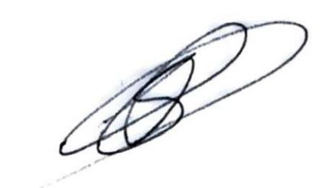  Signed: | S. Pickard | Date: | July 2021

